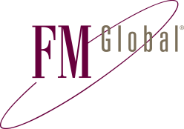
KANSAS BOARD OF REGENTS
Factory Mutual Insurance Company
12645 Olive Boulevard Ste 400
St. Louis, MO 63141 USA
T: +1 (1)314 453 9660 www.fmglobal.com

Send Request To: dawn.stilwell@fmglobal.com

Certificate Request

Insured Information
University | Wichita State University
Facility Name | Main Campus
Facility Address | 1845 Fairmount St
City, State, ZIP | Wichita, KS 67260

Certificate Holder Information
Certificate Holder Name | Wichita State University
Attention | Board of Trustee
Address | 1845 N Fairmount
City, State, ZIP | Wichita, KS 67260

Basic Certificate Information
Type of Certificate | Loss Payee
Notices Required | Not Applicable
Description of Property Covered | Bonds to finance the construction of the John Bardo Center
Additional Information

Description of Property Covered
Property Value to be shown on Certificate (Limit of Liability) | 45,000,000
Coverage to be evidenced on Certificate | Personal Property (Contents, equip, etc.)  Please choose one.

