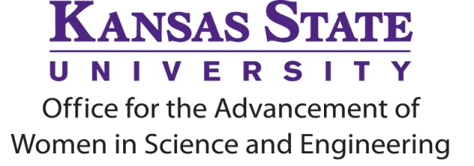
ADVANCE Postdoctoral Researcher Travel Funds
Fall 2023 Request for Proposals for
Travel January 2024 to December 2024

The K-State Office for the Advancement of Women in Science and Engineering (KAWSE) is pleased to issue the Request for Proposals for the Fall 2023 ADVANCE Postdoctoral Researcher Travel Funds. The KAWSE Office works to increase the participation, retention and advancement of girls and women in Science, Technology, Engineering and Math (STEM) disciplines.

Purpose of Award
The purpose of this award is to enhance the postdoctoral researcher experience and enrich the lives of women in STEM disciplines by providing funds for travel to a professional conference. Factors that enhance the postdoctoral researcher experience could include the purpose of the meeting and the extent to which postdoctoral researchers will participate in informal and formal networking opportunities. Factors that lead to enriching the lives of women in STEM disciplines could include participating in professional development workshops relevant to gender inequality and inequity, for example.

Up to $500 will be provided by the KAWSE Office toward the expenses associated with presentation at a professional conference. The deadline for the submission of proposals is October 31, 2023, for travel scheduled January 2024 through December 2024. Preference will be given to first-time applicants and the number of awards is contingent on funding.

Eligibility
- Postdoctoral researchers in STEM departments in the Colleges of Agriculture; Architecture, Planning and Design; Arts & Sciences; Engineering; Health and Human Sciences; and Veterinary Medicine*.
(visit https://www.k-state.edu/kawse/advance/postdoc_travel.html for eligible departments)
*If you are unsure about your eligibility, we would be more than happy to help you determine if you are eligible. Please call us (785-532-6088) or send us an email (kawse@ksu.edu).

- Must be a current Postdoctoral Researcher at K-State when the conference occurs in order to receive reimbursement for travel and offer professional development for KAWSE (see below).

Application Process
Postdoctoral Researchers should send a proposal (no more than 4 pages in length) using the provided application form by email to kawse@ksu.edu by October 31, 2023, at 5pm. Proposals will be reviewed by a screening committee. Please find the application form, sample applications, and the rubric used by the screening committee on our website at https://www.k-state.edu/kawse/advance/postdoc_travel.html.

Requirements upon Returning from Conference
With assistance and guidance from KAWSE, the postdoctoral researchers receiving KAWSE Travel Funds will organize and facilitate a Career Chat for graduate students and/or undergraduate students about a topic relevant to enriching the lives of women in STEM disciplines, such as “How to Navigate a Professional Conference,” “Tips for Informal/Formal Networking at Conferences,” or topics based on your attendance at relevant professional development workshops at the conference. Depending on timing of the conference attended, the Career Chat will either be in the same semester or the following semester.

Career Chat Time Frame**
Spring 2024 or Fall 2024
**Postdoctoral Research Travel Fund Awardee & KAWSE Program Coordinator collaborate to offer this event

Award Application Time Frame
September - call for applications on ADVANCE listserv
October 31, 2023 - application materials due per online application specifications
November/December- review of applications by KAWSE Postdoctoral Researcher Travel Fund Screening Committee
December - notification to applicants of decision
January – public announcement of KAWSE Postdoctoral Researcher Travel Fund Award
September – honoree(s) recognized at KAWSE’s Women’s Recognition Ceremony

Need additional information? Please contact
kawse@ksu.edu • KAWSE • 215 Fairchild Hall • 785-532-6088

