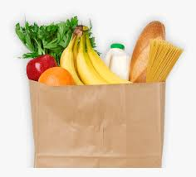
Grocery and International Food Stores
Aldi
140 E. Poyntz Ave

Dillons Food Store
1101 Westloop

Dillons Food Store
130 Sarber Ln

Hy-Vee Grocery
601 N 3rd Place

La Estrella
312 Tuttle Creek Blvd

Los 3 Amigos Mexican Grocery
1106 Laramie St

Mama Fang’s Asian Market
2304 Stagg Hill Rd

Target Grocery
800 Commons Pl

Walmart
101 Bluemont Ave

Yi’s Oriental Market
1030 Colorado St

Halal Options:

Islamic Center of Manhattan (ICM)
1224 Hylton Heights Rd

Mama Fang’s Asian Market
2304 Stagg Hill Rd

Walmart (frequently has Halal meat)
101 Bluemont Ave

Other Options:

Downtown Farmer’s Market (Local food producers and crafters)
3rd and Leavenworth St
Saturdays from 9:00 to 1:00 (November through March)
Saturday 8:00 to 1:00 (April through October)
Wednesday 4:00 to 7:00 (May through September)

Cat’s Cupboard
https://www.k-state.edu/cats-cupboard/
Provides immediate access to food items as well as personal hygiene items at no cost.

